慈文國民中學 英語科 七下補考題庫(詳解) 年 班 座號： 姓名：

- 字彙選擇
- ( )A: Can you get me a of milk from the shop? B: All right. (Ａ) tub (Ｂ) bottle (Ｃ) slice (Ｄ) plate
答案：(Ｂ)
- ( )A: Look! The kids are making . B: Nice. Let’s join them.
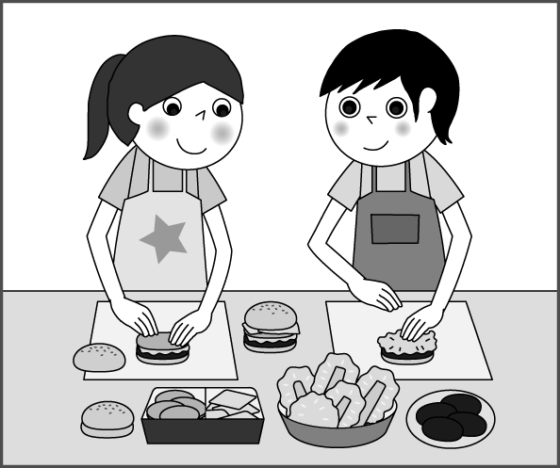
(Ａ) chocolate (Ｂ) ice cream (Ｃ) cookies (Ｄ) hamburgers
答案：(Ｄ)
- ( )Look at the picture. The boy is .
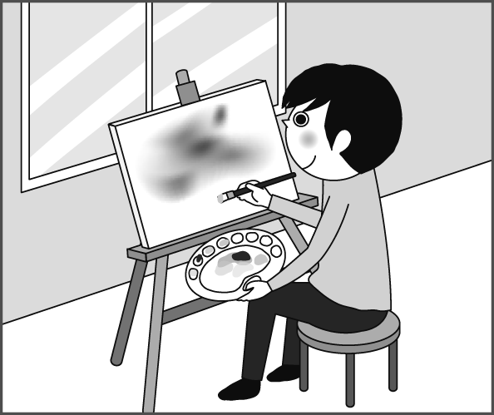
(Ａ) painting (Ｂ) exercising (Ｃ) swimming (Ｄ) showering
答案：(Ａ)
- ( )A: Where did you go last Saturday? B: We visited a mountain and to the top.
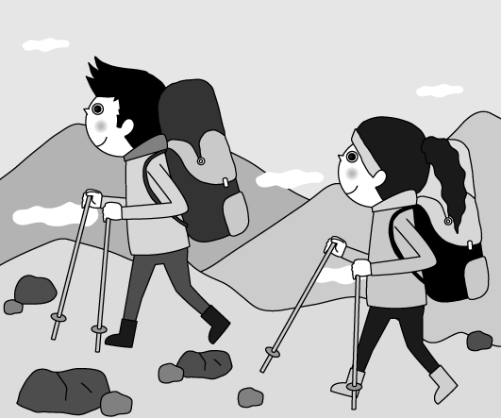
(Ａ) rowed (Ｂ) hiked (Ｃ) planted (Ｄ) camped
答案：(Ｂ)
- ( )A: How can I make a cake? There isn’t any flour at home. B: You can some from James. (Ａ) lend (Ｂ) borrow (Ｃ) want (Ｄ) need
答案：(Ｂ)
- ( )I need some . The candy is too sweet. (Ａ) sugar (Ｂ) salt (Ｃ) cream (Ｄ) water
答案：(Ｄ)
- 文法選擇
- ( )A: did you stop? B: I am tired. I need some rest. (Ａ) Which (Ｂ) Why (Ｃ) When (Ｄ) Where
答案：(Ｂ)
- ( )Barry woke up at four this morning, he needs some sleep now. (Ａ) because (Ｂ) but (Ｃ) besides (Ｄ) so
答案：(Ｄ)
- ( )A: is your favorite basketball player? B: He is 181 centimeters. (Ａ) How big (Ｂ) How tall (Ｃ) How long (Ｄ) How often
答案：(Ｂ)
- ( )A: is the popcorn? B: It is 85 dollars. (Ａ) How much (Ｂ) How many (Ｃ) Which (Ｄ) What
答案：(Ａ)
- ( )A: How often do you walk your dog? B: (Ａ) Late at night. (Ｂ) This Friday. (Ｃ) Once or twice. (Ｄ) Every two days.
答案：(Ｄ)
- ( )My grandfather a few years ago. My family was very sad. (Ａ) die (Ｂ) dies (Ｃ) died (Ｄ) is dying
答案：(Ｃ)
- ( )Nigel has thin lips, but his daughter . (Ａ) do (Ｂ) don’t (Ｃ) does (Ｄ) doesn’t
答案：(Ｄ)
- ( )A: do you like, cake or cookies? B: I like cookies. (Ａ) How (Ｂ) What (Ｃ) Which (Ｄ) How much
答案：(Ｃ)
- ( )A: Fiona build the dog house? B: Yes, she did. (Ａ) Didn’t (Ｂ) Does (Ｃ) Was (Ｄ) Can’t
答案：(Ａ)
- 對話與完成句子
- ( )Leo: Maya: They shower twice a day. (Ａ) What do they do after work? (Ｂ) When do they take a shower? (Ｃ) Do they shower in the morning? (Ｄ) How often do they take a shower?
答案：(Ｄ)
- ( )Ted: are you, Amy? Amy: One hundred and fifty-four centimeters. (Ａ) How old (Ｂ) How tall (Ｃ) How long (Ｄ) How strong
答案：(Ｂ)
- ( )A: B: Me too. I wake up at six every day. (Ａ) I have two sides. (Ｂ) I’m seldom tired. (Ｃ) I’m a morning person. (Ｄ) I change into a bad guy at night.
答案：(Ｃ)
- ( )Lily: Jeff: It’s too sad, so I don’t like it. (Ａ) Who likes the story? (Ｂ) Who wrote the story? (Ｃ) What is the story about? (Ｄ) Why don’t you like the story?
答案：(Ｄ)
- ( )David: Clerk: They’re one hundred dollars. (Ａ) Where are the flowers? (Ｂ) What are these flowers? (Ｃ) Who are these flowers for? (Ｄ) How much are these flowers?
答案：(Ｄ)
- ( )Ella: Can I have a look at that blue bag, please? Clerk: Sure. (Ａ) Here you go. (Ｂ) See you later. (Ｃ) That’s nice of you. (Ｄ) Thank you and have a good day.
答案：(Ａ)
- ( )A: Hey, Tony. B: I’m going to the candy shop. Do you want some chocolate? A: No, thanks. (Ａ) Here it is. (Ｂ) What’s up? (Ｃ) See you tonight. (Ｄ) What else do you need?
答案：(Ｂ)
- ( )John: How do you like the painting? Stella: (Ａ) It’s very beautiful. (Ｂ) It’s a painting by Milo. (Ｃ) Yes. I like bright colors. (Ｄ) You can see it in Milo Museum.
答案：(Ａ)
- ( )A: I met the famous singer Rick Monty on the street yesterday. B: Really? You’re so lucky. (Ａ) How come? (Ｂ) You know what? (Ｃ) What did you say? (Ｄ) What happened?
答案：(Ｂ)
- ( )Clerk: Hi. Isaac: I want some ice cream, please. (Ａ) May I help you? (Ｂ) Can you help me? (Ｃ) For here or to go? (Ｄ) Can I have some sweet food?
答案：(Ａ)
- ( )Joe: Emma: I flew a kite with my friend there. (Ａ) What did you do at the park? (Ｂ) Can you go to the park with me? (Ｃ) How often do you go to the park? (Ｄ) Did you go to the park yesterday?
答案：(Ａ)
- ( )Ava: This book is great. Leo: It is. What about you? Ava: Me too. (Ａ) I can show you. (Ｂ) Who is the writer? (Ｃ) I like the second part. (Ｄ) Which is your favorite book?
答案：(Ｃ)
- ( )A: B: Sometimes I play music, and sometimes I cook for my family. (Ａ) What can you do? (Ｂ) How often do you exercise? (Ｃ) What are you doing now? (Ｄ) What do you do after work?
答案：(Ｄ)
解析：根據回覆「有時候我會演奏音樂，有時我會為家人煮菜。」可知答案選(Ｄ)你平常下班都做些什麼？(Ａ)你會做什麼？(Ｂ)你多久運動一次？(Ｃ)你現在在做什麼？
- ( )A: How many pineapples do you need? B: (Ａ) Here you go. (Ｂ) I need only one. (Ｃ) We don’t have any. (Ｄ) There are too many.
答案：(Ｂ)
- ( )Sam: Meg: She paints or swims. (Ａ) What can she do? (Ｂ) Does she play sports? (Ｃ) Does she have strong arms? (Ｄ) What does she do on weekends?
答案：(Ｄ)
- ( )Ivy: Oscar: Wow, you are an early bird. (Ａ) I usually have dinner at seven. (Ｂ) I sometimes go to bed after twelve. (Ｃ) I get up before six o’clock every day. (Ｄ) I walk my dog for thirty minutes every afternoon.
答案：(Ｃ)

