桃園市立慈文國中 112學年度八年級第二學期補考題庫 年 班 座號： 姓名：

- ( ) Look at the picture. What does the woman have for lunch?
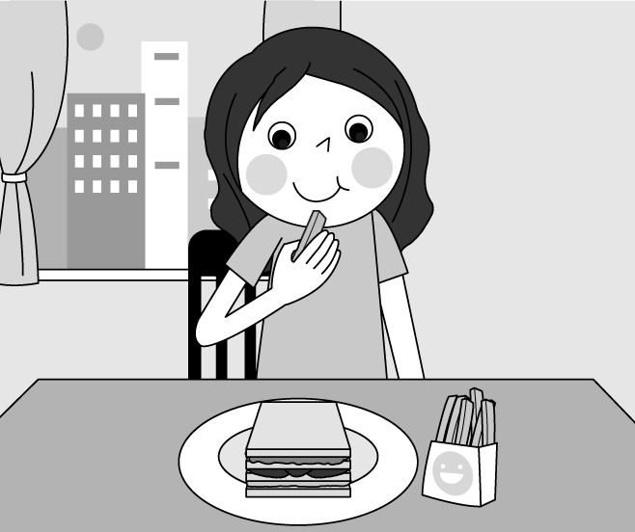
(Ａ) Eggs on toast with fries. (Ｂ) A ham sandwich with fries. (Ｃ) Eggs on toast with an apple pie. (Ｄ) A ham sandwich with an apple pie.
- ( ) We didn’t have a picnic yesterday. There was rain in the morning, and the grass was too for a picnic. (Ａ) wet (Ｂ) far (Ｃ) wide (Ｄ) deep
- ( ) Ben is watching a video about insects. In the video, hundreds of are flying back to their home. (Ａ) ants (Ｂ) bees (Ｃ) spiders (Ｄ) snakes
- ( ) Kelly was tired and today, so she went home earlier than before. (Ａ) wise (Ｂ) weak (Ｃ) slow (Ｄ) brave
- ( ) Look at the picture. What is the man painting?
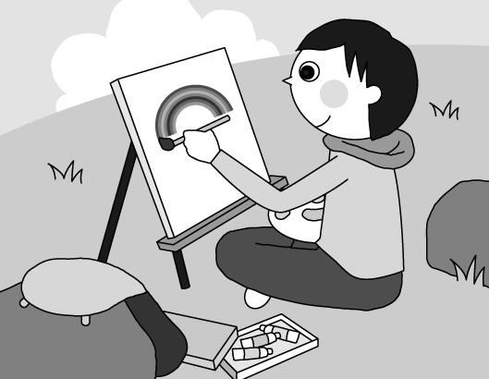
(Ａ) Stars. (Ｂ) Rocks. (Ｃ) The grass. (Ｄ) A rainbow.
- ( ) Max: Can we buy this black sofa for our new house? Mia: Sure. It’s just the right . (Ａ) size (Ｂ) news (Ｃ) space (Ｄ) service
- ( ) Look at the picture. What happened to the girl?
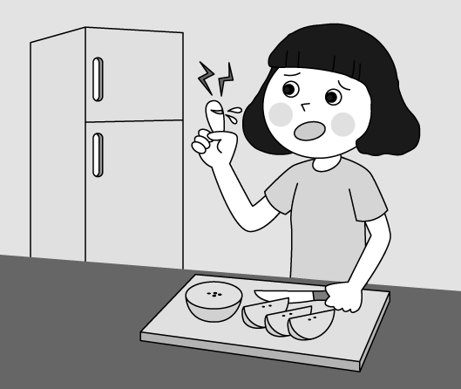
(Ａ) She cut her finger. (Ｂ) She broke her nail. (Ｃ) She had a sore throat. (Ｄ) She had a runny nose.
- ( ) Nina: Oh my! Stop watering the plants. Too much water can kill them. Chris: Sorry, I didn’t know that. I was just trying to be . (Ａ) simple (Ｂ) helpful (Ｃ) honest (Ｄ) common
- ( ) I didn’t to fail the Chinese test. I thought I did well. (Ａ) push (Ｂ) allow (Ｃ) expect (Ｄ) explain
- ( ) Living in a big city is than living in the mountains. (Ａ) convenient (Ｂ) more convenient (Ｃ) the more convenient (Ｄ) the most convenient
- ( ) May: Which is dish in the restaurant? Jay: The pork noodles. They cost more than NT$200 a bowl. (Ａ) expensive (Ｂ) more expensive (Ｃ) the most expensive (Ｄ) more and more expensive
- ( ) Thomas is the best singer in our country. He sings of all. (Ａ) beautiful (Ｂ) beautifully (Ｃ) more beautifully (Ｄ) the most beautifully
- ( ) Hank: I don’t like Mr. Hill. He always makes us a lot of reports. Irene: But I like him. His class is fun and interesting. (Ａ) doing (Ｂ) does (Ｃ) do (Ｄ) to do
- ( ) These ten players are top players; of them are good at throwing a ball. (Ａ) all (Ｂ) both (Ｃ) much (Ｄ) few
- ( ) Ken: Most of the workers don’t like their boss, Mr. Coleman, ? Flora: Well, the truth is that they all like him. (Ａ) does he (Ｂ) do they (Ｃ) doesn’t he (Ｄ) don’t they
- ( ) Jill: Let’s not swim in the lake. The water is deep. Tom: Let’s just sit on the rocks and have our lunch. (Ａ) I agree. (Ｂ) That sounds nice. (Ｃ) Thanks for saving me. (Ｄ) The fish won’t bite us.
- ( ) Paul: The weather is really bad. Are you still going surfing later? Rachel: No. (Ａ) It’s nothing. (Ｂ) I’m not worried at all. (Ｃ) Why don’t you do it later? (Ｄ) It’s better to be safe than sorry.
- ( ) Diane: Don’t worry. You’ll do well in the dancing contest. John: OK. (Ａ) I’ll try my best. (Ｂ) Just be yourself. (Ｃ) Let me turn it on. (Ｄ) I should study harder.
- ( ) Nick: Janet: Yes. There’s a boy standing near the door. He must be lost. (Ａ) Is the boy safe there? (Ｂ) Should we call the police? (Ｃ) What’s wrong with the boy? (Ｄ) Do you hear someone crying?
- ( ) Peter: Hey, Rick. I didn’t see you this morning. Rick: I had a stomachache, so I went to the doctor. (Ａ) How are you feeling? (Ｂ) What was the matter? (Ｃ) How’s your stomach now? (Ｄ) Do you feel like taking some rest?
- ( ) Jenna: Karen: Maybe you have a cold. Just drink more water and get some sleep. (Ａ) I have a sore throat and a runny nose. (Ｂ) I fell on the ground and broke my knee. (Ｃ) The bed isn’t comfortable at all, and my neck hurts. (Ｄ) The cold medicine didn’t help. I am still coughing a lot.

(On the farm)
: Hi, Ella. Good to see you again. Did your parents ask you to come and work here?
: I was not happy when my parents had me here last summer, but I started to enjoy farm life after spending two months with animals and plants. So, here I am. Don’t you want me back?
: Of course I do. We miss you and really need your help. You work quickly and .
: Thanks. What can I help you with today?
: Could you help me guavas and peaches? The typhoon is coming.
: Let’s hurry.
（ ）(１)(Ａ) No one made me. (Ｂ) I didn’t let them come. (Ｃ) Yes. They treated me badly. (Ｄ) I don’t want to talk about it.
（ ）(２)(Ａ) came (Ｂ) come (Ｃ) to come (Ｄ) coming
（ ）(３)(Ａ) slowly (Ｂ) clearly (Ｃ) loudly (Ｄ) carefully
（ ）(４)(Ａ) pick (Ｂ) grow (Ｃ) share (Ｄ) choose
（ ）(５)(Ａ) No problem. (Ｂ) Sounds great. (Ｃ) I feel hungry now. (Ｄ) Don’t be mean to me.

Today is our graduation day. First, I would like to thank our teacher, Mrs. Lin. She so much from us and pushed us to become excellent. What’s more, she allowed us to make , and she always helped us learn from them. I am so thankful for her. She’s the best teacher in the world, ? you, my classmates, thanks for all the memories of the past three years. We laughed, we cried, and sometimes we fought. Let’s cherish our happy memories together. Our future is in our own hands. Believe in yourself. and hold you back. Let’s live life to the full. Happy graduation!
（ ）(１)(Ａ) passed (Ｂ) threw (Ｃ) counted (Ｄ) expected
（ ）(２)(Ａ) grades (Ｂ) points (Ｃ) excuses (Ｄ) mistakes
（ ）(３)(Ａ) is she (Ｂ) isn’t she (Ｃ) does she (Ｄ) doesn’t she
（ ）(４)(Ａ) As for (Ｂ) Just like (Ｃ) Thanks to (Ｄ) Because of
（ ）(５)(Ａ) Just try your best (Ｂ) Never hide your true self (Ｃ) Don’t let others define you (Ｄ) We’ll always be there for you

I am Remy, and I am a chef at Gusteau’s. The other cooks are all friendly to me. At first, they were a little worried because I’m a rat. Even a knife is bigger and heavier than I. Besides that, food safety is the most important thing at Gusteau’s. So, I wash my hands many times before I start cooking, and stay away from my rat friends when I am working.
But what really makes me a good chef? It’s my sense of smell. I have the best sense of smell in the restaurant, and it helps me with the cooking. Many people come to Gusteau’s just for my steak. It smells good and tastes delicious. We have much more customers than before. Gusteau’s is now the most popular restaurant in town, and I am for sure the happiest rat chef in the world.
（ ）(１) Which word（字）is closest in meaning（意思）to chef? (Ａ) Rat. (Ｂ) Cook. (Ｃ) Menu. (Ｄ) Waiter.
（ ）(２) What were the other cooks at Gusteau’s worried about when Remy started working?
a. He might not be good at cooking.
b. Many kitchen tools（工具）are heavier than he.
c. The customers might be scared of him.
d. His food might not be clean enough for people to eat.
(Ａ) a. and b. (Ｂ) a. and c. (Ｃ) b. and d. (Ｄ) c. and d.
（ ）(３) Which is true? (Ａ) The most popular dish at Gusteau’s is a beef dish. (Ｂ) Every cook in the kitchen has a better sense of smell than Remy. (Ｃ) Gusteau’s has a better chef than any other restaurant in the world. (Ｄ) Remy doesn’t enjoy his job because people at his work aren’t nice to him.

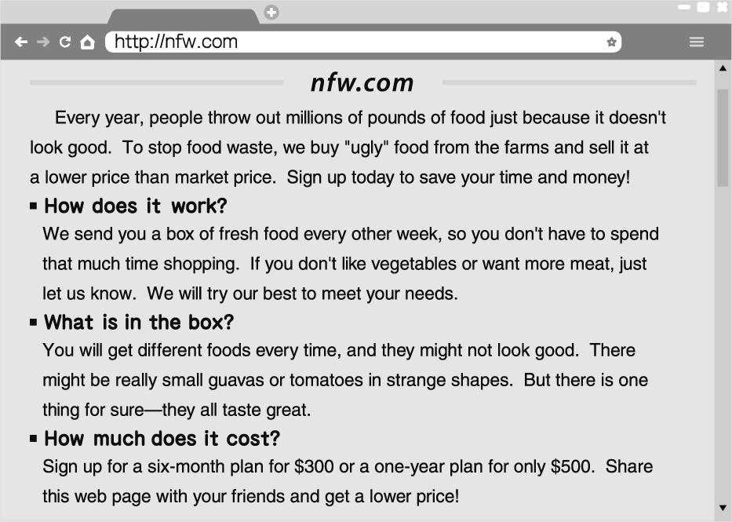
（ ）(１) What is the web page mainly（主要地）about? (Ａ) Cooking delicious food. (Ｂ) Ways to stop food waste. (Ｃ) Selling food at a lower price. (Ｄ) Telling people to eat healthy food.
（ ）(２) Mike just got a box of food from nfw.com. Which food may NOT be in the box? (Ａ) Bread. (Ｂ) Pork. (Ｃ) Beans. (Ｄ) Watermelons.
（ ）(３) What do we know about nfw.com from the reading? (Ａ) They can help fight food waste. (Ｂ) They don’t let people choose the food. (Ｃ) They send out a box of food every week. (Ｄ) They make a lot of money by selling food.

解答
1~5 BABBD
6~10 AABCB
11~15 CDCAB
16~21 ADADBA
22 ABDAA
23 DDBAC
24 BCA
25 CAA

